**CREATE CREDENTIALS FOR THE GITHUB & DOCKER:-**

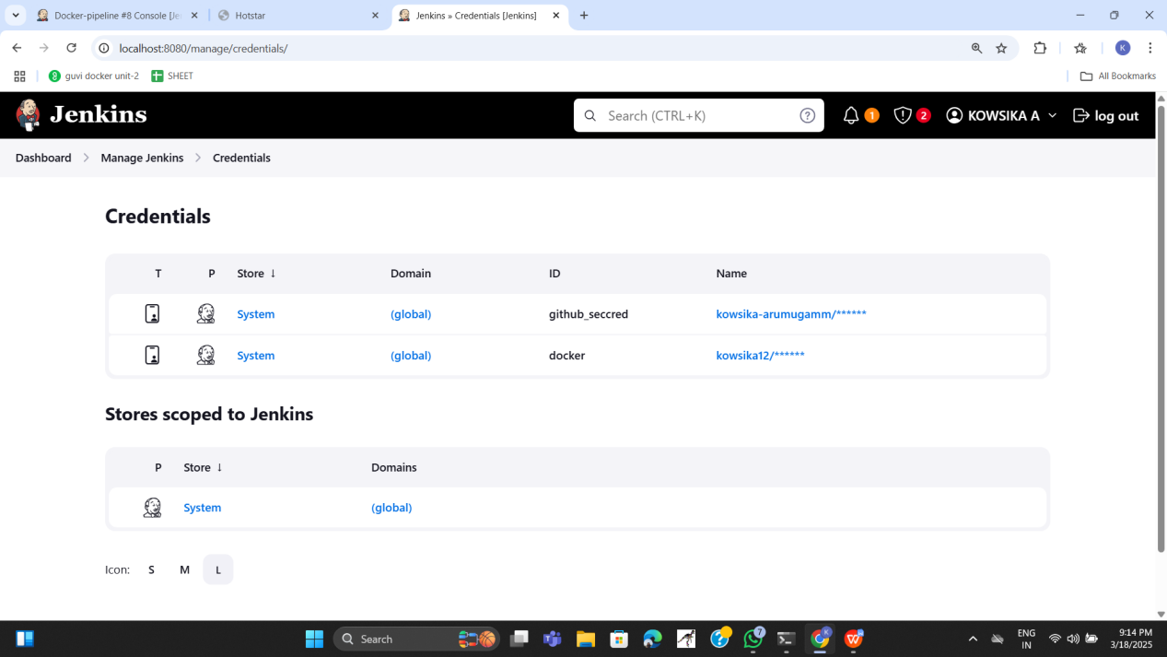

**PUSH ALL THE FILES TO GITHUB:-**

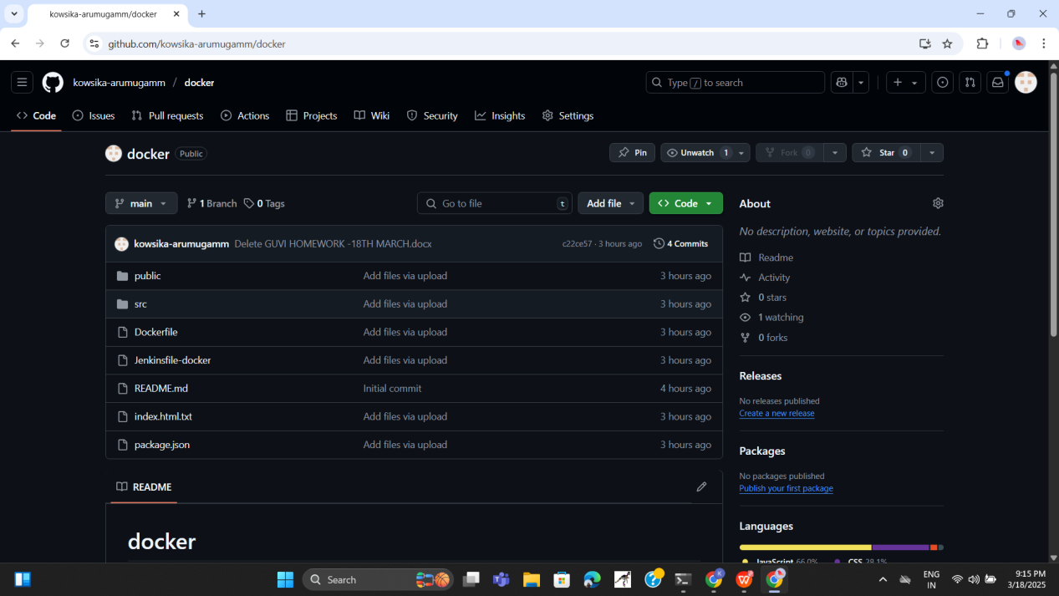

**TO CHANGE PIPESCRIPT:-**

In Jenkins click on new item -> pipeline -> and in the below script section put this script:

(modify according to your links and names)

pipeline {

    agent any

    tools {

        jdk 'jdk17'

        nodejs 'node20'

    }

    stages {

        stage('Clean Workspace') {

            steps {

                script {

                    echo "Cleaning workspace..."

                    deleteDir() // Deletes everything in the Jenkins workspace before starting

                }

            }

        }

        stage('Git Checkout') {

            steps {

                script {

                    git branch: 'main',

                        credentialsId: 'github\_seccred',

                        url: '[https://github.com/justicesecops-10/day2-app-depployement-docker.git](https://github.com/justicesecops-10/day2-app-depployement-docker.git" \t "https://mail.google.com/mail/u/0/?tab=rm&ogbl" \l "inbox/_blank)'

                }

            }

        }

        stage('Install Node') {

            steps {

                script {

                    sh '''

                    if [ -f package.json ]; then

                        echo "package.json found. Running npm install..."

                        npm install

                    else

                        echo "ERROR: package.json is missing. Skipping npm install."

                        exit 1

                    fi

                    '''

                }

            }

        }

        stage('Docker Build & Push') {

            steps {

                script {

                    withDockerRegistry(credentialsId: 'docker', toolName: 'docker') {

                        def imageName = "justiceexam10/jusjes"

                        def tag = "latest"

                        sh "docker build -t ${imageName} ."

                        sh "docker tag ${imageName} ${imageName}:${tag}"

                        sh "docker push ${imageName}:${tag}"

                    }

                }

            }

        }

   stage('Deploy Docker Container') {

    steps {

        script {

            // Stop and remove the existing container if it's running

            sh "docker stop jusjes\_container || true"

            sh "docker rm jusjes\_container || true"

            // Run the new container

            sh "docker run -d --name jusjes\_container -p 3001:3000 justiceexam10/jusjes:latest"

        }

    }

}

}

}

**GIVE BUILD NOW:-**

**if build not run use this commands in linux**

**sudo usermod -aG docker jenkins**

**sudo chmod 666 /var/run/docker.sock**

**sudo systemctl restart jenkins**

**sudo systemctl status jenkins**

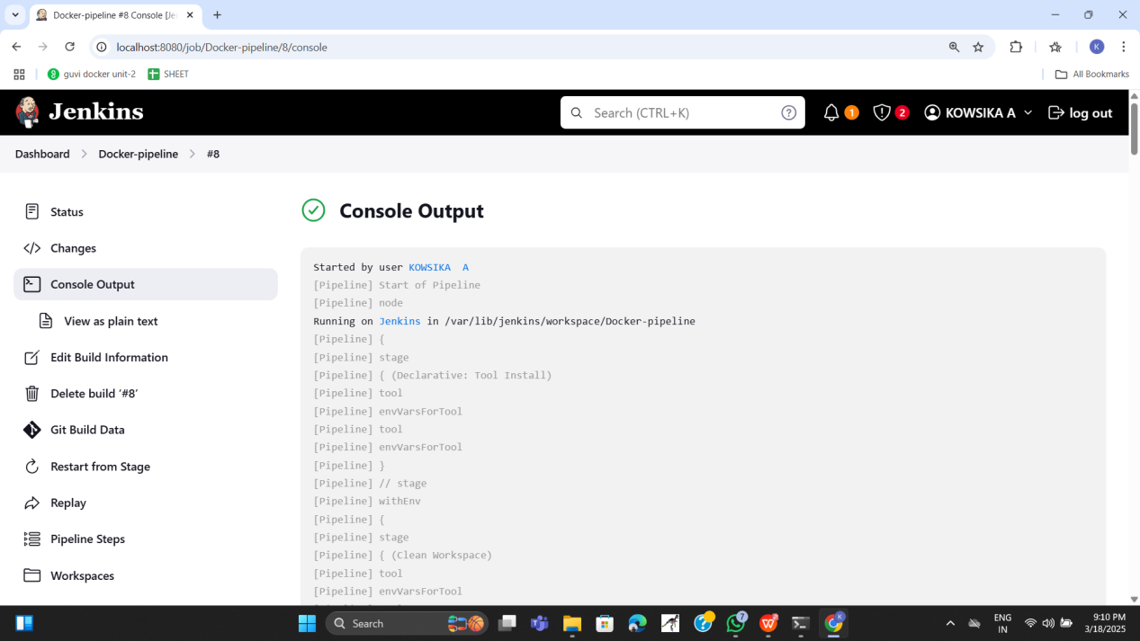

**OUTPUT:-**

